All Regional Engineers
John D. Baranzelli
Special Provision for Accessible Pedestrian Signals (APS)
September 27, 2013

This special provision was developed by the Bureau of Operations and the Bureau of Design and Environment to provide statewide requirements for accessible pedestrian signals (APS). It has been revised to fit with the 2012 Standard Specifications, to agree with the Bureau of Operations Policy on Pedestrian Pushbutton Locations and Accessible Pedestrian Signals, and to incorporate new accessibility requirements.

This special provision should be inserted into all contracts using APS.

The installation of APS at signalized intersections should be based on the Bureau of Operations Policy on Pedestrian Pushbutton Locations and Accessible Pedestrian Signals.

Designer Note: Pedestrian pushbutton posts and pedestrian signal heads are not part of this work. If they are needed, use the appropriate pay items as per Sections 876 and 881 of the Standard Specifications.

The districts should include the BDE Check Sheet marked with the applicable special provisions for the January 17, 2014 and subsequent lettings. The Project Development and Implementation Section will include a copy in the contract.

This special provision will be available on the transfer directory
September 27, 2013.

80099m

ACCESSIBLE PEDESTRIAN SIGNALS (APS) (BDE)

Effective: April 1, 2003
Revised: January 1, 2014

Description. This work shall consist of furnishing and installing accessible pedestrian signals (APS). Each APS shall consist of an interactive vibrotactile pedestrian pushbutton with speaker, an informational sign, a light emitting diode (LED) indicator light, a solid state electronic control board, a power supply, wiring, and mounting hardware. The APS shall meet the requirements of the MUTCD and Sections 801 and 888 of the Standard Specifications, except as modified herein.

Electrical Requirements. The APS shall operate with systems providing 95 to 130 VAC, 60 Hz and throughout an ambient air temperature range of -29 to +160 °F (-34 to +70 °C).

The APS shall contain a power protection circuit consisting of both fuse and transient protection.

Audible Indications. A pushbutton locator tone shall sound at each pushbutton.

If two accessible pedestrian pushbuttons are placed less than 10 ft (3 m) apart or placed on the same pole, the audible walk indication shall be a speech walk message.

A clear, verbal message shall be used to communicate the pedestrian walk interval. This message shall sound throughout the WALK interval only. The verbal message shall be modeled after: “’Street Name.’ Walk Sign is on to cross “Street Name’.” No other messages shall be used to denote the WALK interval.

Where two accessible pedestrian pushbuttons are separated by at least 10 ft (3 m), the walk indication shall be an audible percussive tone. It shall repeat at 8 to 10 ticks per second with a dominant frequency of 880 Hz.

Automatic volume adjustments in response to ambient traffic sound level shall be provided up to a maximum volume of 100 dBA. Locator tone and verbal messages shall be no more than 5 dB louder than ambient sound.

Pedestrian Pushbutton. Pedestrian pushbuttons shall be at least 2 in. (50 mm) in diameter or width. The force required to activate the pushbutton shall be no greater than 3.5 lb (15.5 N).

A red LED shall be located on or near the pushbutton which, when activated, acknowledges the pedestrians request to cross the street.

Signage. A sign shall be located immediately above the pedestrian pushbutton and parallel to the crosswalk controlled by the pushbutton. The sign shall be one of the following standard MUTCD designs:
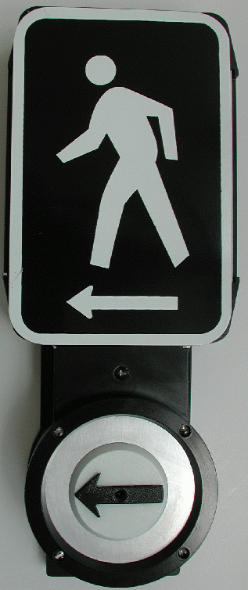
PUSH
BUTTON
FOR

Tactile Arrow. A tactile arrow, pointing in the direction of travel controlled by a pushbutton, shall be provided either on the pushbutton or its sign.

Vibrotactile Feature. The pushbutton shall pulse when depressed and shall vibrate continuously throughout the WALK interval.

Method of Measurement. This work will be measured for payment as each, per pushbutton.

Basis of Payment. This work will be paid for at the contract unit price per each for ACCESSIBLE PEDESTRIAN SIGNALS.

80099

