I agree

We have seen this in D1 as well.  The macro has worked for me from day one without any issues.  I think some of the initial settings are the problem.

If I narrow down the culprit, I will let you know.

**From:** Deters, Benjamin J.   
**Sent:** Monday, November 18, 2019 2:10 PM  
**To:** Ley, Shawn A <[Shawn.Ley@illinois.gov](mailto:Shawn.Ley@illinois.gov)>; Aqueel, Fawad F <[Fawad.Aqueel@illinois.gov](mailto:Fawad.Aqueel@illinois.gov)>  
**Cc:** Rostkowski, Radoslaw <[Radoslaw.Rostkowski@illinois.gov](mailto:Radoslaw.Rostkowski@illinois.gov)>; Nafakh, Ahmad <[Ahmad.Nafakh@illinois.gov](mailto:Ahmad.Nafakh@illinois.gov)>; Bower, Matthew L <[Matthew.Bower@illinois.gov](mailto:Matthew.Bower@illinois.gov)>; Steffen, Mona K <[Mona.Steffen@illinois.gov](mailto:Mona.Steffen@illinois.gov)>  
**Subject:** RE: ADA Design and labeling

Not sure why, but I ran the macros again after doing some editing to my proposed design and now the macros is working properly (i.e., removing all the “slope =” text. I’m not sure if this had some thing to do with me opening up the find/replace toolbox manually…that is the only thing I can think of that would have been different than the first time running it.

Benjamin J. Deters, P.E.

Senior Project Squad Leader

District 7 Bureau of Program Development

217.342.8361

[Benjamin.Deters@illinois.gov](mailto:Benjamin.Deters@illinois.gov)

P Please consider the environment before printing this e-mail.

**From:** Deters, Benjamin J.   
**Sent:** Monday, November 18, 2019 1:54 PM  
**To:** Ley, Shawn A <[Shawn.Ley@illinois.gov](mailto:Shawn.Ley@illinois.gov)>; Aqueel, Fawad F <[Fawad.Aqueel@illinois.gov](mailto:Fawad.Aqueel@illinois.gov)>  
**Cc:** Rostkowski, Radoslaw <[Radoslaw.Rostkowski@illinois.gov](mailto:Radoslaw.Rostkowski@illinois.gov)>; Nafakh, Ahmad <[Ahmad.Nafakh@illinois.gov](mailto:Ahmad.Nafakh@illinois.gov)>; Bower, Matthew L <[Matthew.Bower@illinois.gov](mailto:Matthew.Bower@illinois.gov)>; Steffen, Mona K <[Mona.Steffen@illinois.gov](mailto:Mona.Steffen@illinois.gov)>  
**Subject:** RE: ADA Design and labeling

No, the find/replace text box does not come up with selecting “run” on the macros screen. The “select by attributes” box flashes on the screen for about a second then disappears, but that is all that is shown when the macros is run. Once the macros is done running, this is the only box that pops up:

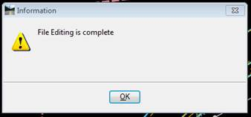

Benjamin J. Deters, P.E.

Senior Project Squad Leader

District 7 Bureau of Program Development

217.342.8361

[Benjamin.Deters@illinois.gov](mailto:Benjamin.Deters@illinois.gov)

P Please consider the environment before printing this e-mail.

**From:** Ley, Shawn A   
**Sent:** Monday, November 18, 2019 1:47 PM  
**To:** Deters, Benjamin J. <[Benjamin.Deters@Illinois.gov](mailto:Benjamin.Deters@Illinois.gov)>; Aqueel, Fawad F <[Fawad.Aqueel@illinois.gov](mailto:Fawad.Aqueel@illinois.gov)>  
**Cc:** Rostkowski, Radoslaw <[Radoslaw.Rostkowski@illinois.gov](mailto:Radoslaw.Rostkowski@illinois.gov)>; Nafakh, Ahmad <[Ahmad.Nafakh@illinois.gov](mailto:Ahmad.Nafakh@illinois.gov)>; Bower, Matthew L <[Matthew.Bower@illinois.gov](mailto:Matthew.Bower@illinois.gov)>; Steffen, Mona K <[Mona.Steffen@illinois.gov](mailto:Mona.Steffen@illinois.gov)>  
**Subject:** RE: ADA Design and labeling

Are you seeing the OK box come up when you run this macro?

It does prompt for you to click OK for each of the text edits…

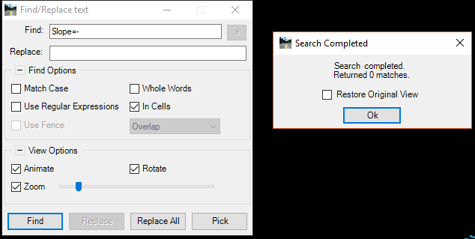

I had a problem with mine not displaying on my screen that I have since corrected…

**From:** Deters, Benjamin J.   
**Sent:** Monday, November 18, 2019 1:32 PM  
**To:** Ley, Shawn A <[Shawn.Ley@illinois.gov](mailto:Shawn.Ley@illinois.gov)>; Aqueel, Fawad F <[Fawad.Aqueel@illinois.gov](mailto:Fawad.Aqueel@illinois.gov)>  
**Cc:** Rostkowski, Radoslaw <[Radoslaw.Rostkowski@illinois.gov](mailto:Radoslaw.Rostkowski@illinois.gov)>; Nafakh, Ahmad <[Ahmad.Nafakh@illinois.gov](mailto:Ahmad.Nafakh@illinois.gov)>; Bower, Matthew L <[Matthew.Bower@illinois.gov](mailto:Matthew.Bower@illinois.gov)>; Steffen, Mona K <[Mona.Steffen@illinois.gov](mailto:Mona.Steffen@illinois.gov)>  
**Subject:** RE: ADA Design and labeling

Shawn,

Below is a screenshot of both my Macros toolbox and the Find/Replace Text toolbox I open from the Edit tab.

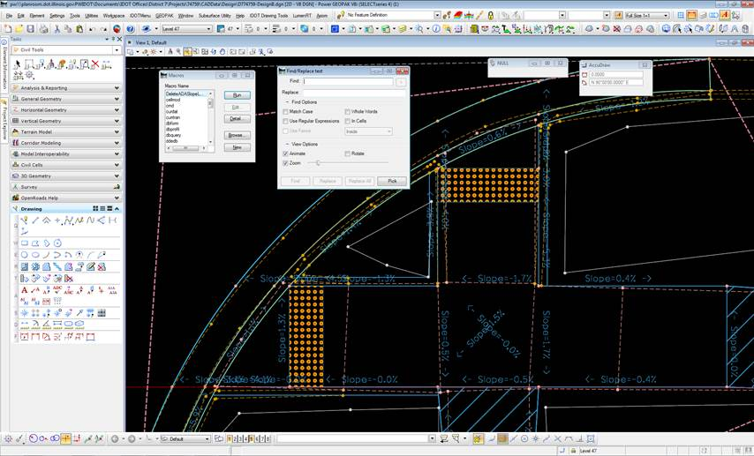

As you can see the Find/Replace box is blank. Is this something that should be filled in with the macro installed?

Thank You,

Benjamin J. Deters, P.E.

Senior Project Squad Leader

District 7 Bureau of Program Development

217.342.8361

[Benjamin.Deters@illinois.gov](mailto:Benjamin.Deters@illinois.gov)

P Please consider the environment before printing this e-mail.

**From:** Ley, Shawn A   
**Sent:** Monday, November 18, 2019 1:21 PM  
**To:** Deters, Benjamin J. <[Benjamin.Deters@Illinois.gov](mailto:Benjamin.Deters@Illinois.gov)>; Aqueel, Fawad F <[Fawad.Aqueel@illinois.gov](mailto:Fawad.Aqueel@illinois.gov)>  
**Cc:** Rostkowski, Radoslaw <[Radoslaw.Rostkowski@illinois.gov](mailto:Radoslaw.Rostkowski@illinois.gov)>; Nafakh, Ahmad <[Ahmad.Nafakh@illinois.gov](mailto:Ahmad.Nafakh@illinois.gov)>; Bower, Matthew L <[Matthew.Bower@illinois.gov](mailto:Matthew.Bower@illinois.gov)>; Steffen, Mona K <[Mona.Steffen@illinois.gov](mailto:Mona.Steffen@illinois.gov)>  
**Subject:** RE: ADA Design and labeling

Hi Benjamin

Can you send me a screen shot of your Find/Replace dialog box?

It may have something to do with it.

***Shawn Ley***

Regional Engineering Technology Coordinator / [CADD Manager](http://www.idot.illinois.gov/doing-business/procurements/engineering-architectural-professional-services/Consultants-Resources/index)

[**Illinois Department of Transportation**](http://www.dot.il.gov/)

Region One - District One

(847) 705-4008

[Shawn.Ley@illinois.gov](mailto:Shawn.Ley@illinois.gov)

CADD

**From:** Deters, Benjamin J.   
**Sent:** Monday, November 18, 2019 1:05 PM  
**To:** Aqueel, Fawad F <[Fawad.Aqueel@illinois.gov](mailto:Fawad.Aqueel@illinois.gov)>  
**Cc:** Rostkowski, Radoslaw <[Radoslaw.Rostkowski@illinois.gov](mailto:Radoslaw.Rostkowski@illinois.gov)>; Nafakh, Ahmad <[Ahmad.Nafakh@illinois.gov](mailto:Ahmad.Nafakh@illinois.gov)>; Ley, Shawn A <[Shawn.Ley@illinois.gov](mailto:Shawn.Ley@illinois.gov)>; Bower, Matthew L <[Matthew.Bower@illinois.gov](mailto:Matthew.Bower@illinois.gov)>; Steffen, Mona K <[Mona.Steffen@illinois.gov](mailto:Mona.Steffen@illinois.gov)>  
**Subject:** RE: ADA Design and labeling

Fawad,

Here in D7 we had the respective macros installed into Microstation for the ADA design spreadsheet tool to delete the extra lines and clean up the proposed labeling. When running the installed macros, it is successful in deleting the extra lines and circles created from labeling the proposed design information, but does not delete the “SLOPE =” or the “SLOPE=-“ text. If you could advise on how to fix this issue it would be appreciated.

Thank You,

Benjamin J. Deters, P.E.

Senior Project Squad Leader

District 7 Bureau of Program Development

217.342.8361

[Benjamin.Deters@illinois.gov](mailto:Benjamin.Deters@illinois.gov)

P Please consider the environment before printing this e-mail.

**From:** Aqueel, Fawad F   
**Sent:** Thursday, November 14, 2019 2:23 PM  
**To:** Bower, Matthew L <[Matthew.Bower@illinois.gov](mailto:Matthew.Bower@illinois.gov)>; Ley, Shawn A <[Shawn.Ley@illinois.gov](mailto:Shawn.Ley@illinois.gov)>  
**Cc:** Deters, Benjamin J. <[Benjamin.Deters@Illinois.gov](mailto:Benjamin.Deters@Illinois.gov)>; Rostkowski, Radoslaw <[Radoslaw.Rostkowski@illinois.gov](mailto:Radoslaw.Rostkowski@illinois.gov)>; Nafakh, Ahmad <[Ahmad.Nafakh@illinois.gov](mailto:Ahmad.Nafakh@illinois.gov)>  
**Subject:** RE: ADA Design and labeling

I advise that you call our cadd manager and he can walk you through that process.

Our cadd manager is shawn ley and can be reached at 847-705-4498

**Fawad Aqueel, PE, PTOE**

*Plan Preparation Engineer*

*IDOT Bureau of Design*

*Region One/District One*

[Fawad.Aqueel@illinois.gov](mailto:Fawad.Aqueel@illinois.gov)

847-705-4247

**From:** Bower, Matthew L   
**Sent:** Thursday, November 14, 2019 2:21 PM  
**To:** Aqueel, Fawad F <[Fawad.Aqueel@illinois.gov](mailto:Fawad.Aqueel@illinois.gov)>  
**Cc:** Deters, Benjamin J. <[Benjamin.Deters@Illinois.gov](mailto:Benjamin.Deters@Illinois.gov)>  
**Subject:** RE: ADA Design and labeling

I am sorry that is the DeleteADASlopeLines.ba.  correct?  How do we “install” that into Microstation?

**From:** Aqueel, Fawad F   
**Sent:** Thursday, November 14, 2019 2:16 PM  
**To:** Bower, Matthew L <[Matthew.Bower@illinois.gov](mailto:Matthew.Bower@illinois.gov)>  
**Cc:** Deters, Benjamin J. <[Benjamin.Deters@Illinois.gov](mailto:Benjamin.Deters@Illinois.gov)>; Nafakh, Ahmad <[Ahmad.Nafakh@illinois.gov](mailto:Ahmad.Nafakh@illinois.gov)>; Rostkowski, Radoslaw <[Radoslaw.Rostkowski@illinois.gov](mailto:Radoslaw.Rostkowski@illinois.gov)>  
**Subject:** RE: ADA Design and labeling

Im confused by your question.  The macro to remove the unnecessary lines was sent in my last email. The ones to draw the lines are just standard MicroStation tools.

Can you please clarify your question?

Thanks,

**Fawad Aqueel, PE, PTOE**

*Plan Preparation Engineer*

*IDOT Bureau of Design*

*Region One/District One*

[Fawad.Aqueel@illinois.gov](mailto:Fawad.Aqueel@illinois.gov)

847-705-4247

**From:** Bower, Matthew L   
**Sent:** Thursday, November 14, 2019 2:09 PM  
**To:** Aqueel, Fawad F <[Fawad.Aqueel@illinois.gov](mailto:Fawad.Aqueel@illinois.gov)>  
**Cc:** Deters, Benjamin J. <[Benjamin.Deters@Illinois.gov](mailto:Benjamin.Deters@Illinois.gov)>  
**Subject:** RE: ADA Design and labeling

I have been using the ADA Design Spreadsheet and was wondering if I could get a copy of the macro you use for labeling. Thanks.

*Matt Bower*

*Senior Plan Project Squad Leader*

*IDOT - Region 4 - District 7*

400 West Wabash Avenue

Effingham, IL 62401

*Ph. (217) 342-8359*

[Matthew.Bower@illinois.gov](mailto:Matthew.Bower@illinois.gov)

**From:** Aqueel, Fawad F   
**Sent:** Wednesday, November 06, 2019 3:16 PM. <[Phuong.Huynh@illinois.gov](mailto:Phuong.Huynh@illinois.gov)>; [ali.issa@hbmengineering.com](mailto:ali.issa@hbmengineering.com); Janachione, Michael   
**Subject:** ADA Design and labeling

Thank you everyone that participated in the D1 ADA design and labeling class.

Attached for your use is the Training Manual, ADA Tool Excel Spreadsheet, and MicroStation macro to remove the unnecessary lines.

As a reminder this is just another tool for your use and the designer is still responsible to ensure an acceptable design.

The recorded presentation video will be uploaded to youtube and a link will be provided within 1-2 months.

For those consultants that wish to learn more there will be an upcoming ADA Training session through ACEC on December 5 at the IDOT D1 office. You will need to register through ACEC to attend. This one will have the excel portion limited to 1.5 hours and will concentrate on ADA policy.

Thanks,

**Fawad Aqueel, PE, PTOE**

*Plan Preparation Engineer*

*IDOT Bureau of Design*

*Region One/District One*

[Fawad.Aqueel@illinois.gov](mailto:Fawad.Aqueel@illinois.gov)

847-705-4247